BMAV
Bala Ciril Reddy Vadicherla
Manasa Kamepally
Asha Birajdar
Vikram Reddy Kommareddy

Interim Report-1
CISP 660-01: Fall, 2022

<10/12/2022>

Table of Contents

1 Introduction 2
2 Design of the Database 2
2.1 Conceptual Design 2
2.2 Logical Design 3
2.3 Physical Design 3
3 Implementation of the Database 3
4 User Interface 3
4.1 Design 3
4.2 Implementation 4
4.2.1 Reports 4
4.2.2 Forms 4
5 User Manual 4
6 Conclusion 4

General Instructions for the interim/ final report:
- You can use this suggested structure for your report.
- Do NOT delete various sections even when you have not completed them; just leave them blank. Here is what gets completed for various reports:
- Interim Report I: Section 2.1 Only
- Interim Report II: Section 2.1 (Revised), Section 2.2, Section 3 and Section 4.1
- Final Report: All the Sections; revise sections 2.1, 2.2, 3 and 4.1 (if required), fix any issues arising from the presentation and demo
- Remember to spell check and re-read the document for any grammatical errors.
- Be clear and concise.
- Include page numbers.
- Your report should not look fragmented. You may have used many different software applications but you can paste everything in your final MS-Word document. Your report should look professional and impressive.
- Use headings and create your table of contents automatically (In MS-Word, use "Reference" → "Table of Contents" tab).
- Give captions for your diagrams and tables (In MS-Word, use "Reference" → "Insert Caption"). Describe each table you have included.
- Use font size 11 or 12 and single spacing
- Your report is expected to be around 15-20 pages long

1 Introduction
This section tells the reader what this report is about and what it contains. Keep it no more than 1 page.

Include:
- An overview of your project and your report here; this should be brief but should contain just enough details of the project. Keep it non-technical; assume the reader of this section is the CEO who does not know much about DBMS and databases but knows enough about the application.
- Describe the environment of the database application, e.g., Oracle 9i, MS SQL Server, MS Access… Include versions of the software used.
- What are the various sections about? You can give "very-very" short description about each section and how it maps to your project.

2 Design of the Database

2.1 Conceptual Design
This section describes your conceptual schema.

Include:
- The ER diagram. You need to use ABC Flowcharter, Visio or any other modeling tool to make the ER diagram. Paste ABC Flowcharter/ Visio diagram in your MS-Word document.
- If you are using Visio and pasting a schema in an MS-Word document. Choose “Paste Special” and Paste As “Bitmap” or “Picture.”
- Give description of any intricate part of your ER diagram: what design decisions you made and your rationale?

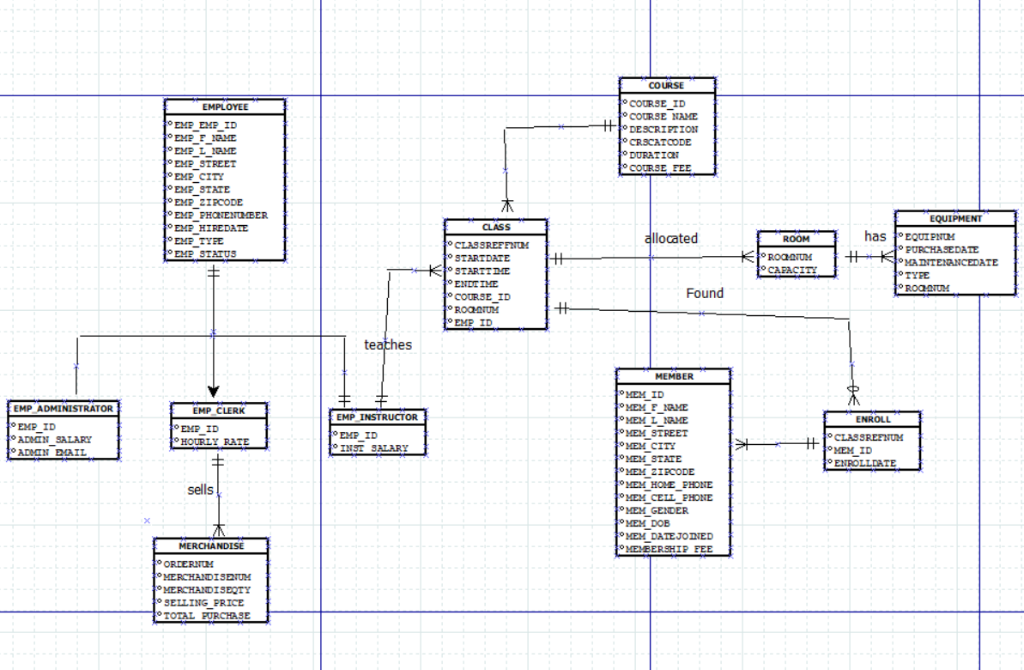

- Data dictionary:

Attribute Name | Data Type |  | Valid Values | NULL Allowed | Description of the attribute
EMP_EMP_ID | VARCHAR | NA |  | No | Employees has a unique sequential four-digit employee ID number
EMP_F_NAME | VARCHAR | 15 |  | No | First name of employee.
EMP_L_NAME | VARCHAR | 10 |  | No | Last name of employee.
EMP_STREET | VARCHAR | 15 |  | No | Employees’ Street Address
EMP_CITY | VARCHAR | 8 |  | No | Employees’ City
EMP_STATE | CHAR | 2 |  | No | Employees’ State
EMP_ZIPCODE | CHAR | 5 |  | No | Employees’ Zip code
EMP_PHONENUMBER | CHAR | 10 |  | No | Employees phone number
EMP_HIREDATE | DATE | NA |  | No | Date that employees are originally hired.
EMP_TYPE | CHAR | 1 |  | No | different types of employees: fitness course instructors(I_), clerks in the fitness store © and administrative personnel( A)
EMP_STATUS | CHAR | 10 |  | No | Employee current status

Attribute Name | Data Type |  | Valid Values | NULL Allowed | Description of the attribute
EMP_EMP_ID | VARCHAR | NA |  | No | Employees has a unique sequential four-digit employee ID number
EMP_F_NAME | VARCHAR | 15 |  | No | First name of employee.
EMP_L_NAME | VARCHAR | 10 |  | No | Last name of employee.
EMP_STREET | VARCHAR | 15 |  | No | Employees’ Street Address
EMP_CITY | VARCHAR | 8 |  | No | Employees’ City
EMP_STATE | CHAR | 2 |  | No | Employees’ State
EMP_ZIPCODE | CHAR | 5 |  | No | Employees’ Zip code
EMP_PHONENUMBER | CHAR | 10 |  | No | Employees phone number
EMP_HIREDATE | DATE | NA |  | No | Date that employees are originally hired.
EMP_TYPE | CHAR | 1 |  | No | different types of employees: fitness course instructors(I_), clerks in the fitness store © and administrative personnel( A)
EMP_STATUS | CHAR | 10 |  | No | Employee current status

Table 1: Data Dictionary for EMPLOYEE Entity Type
Attribute Name | Data Type |  | Valid Values | NULL Allowed | Description of the attribute
EMP_EMP_ID | VARCHAR | NA |  | No | Employees has a unique sequential four-digit employee ID number
EMP_F_NAME | VARCHAR | 15 |  | No | First name of employee.
EMP_L_NAME | VARCHAR | 10 |  | No | Last name of employee.
EMP_STREET | VARCHAR | 15 |  | No | Employees’ Street Address
EMP_CITY | VARCHAR | 8 |  | No | Employees’ City
EMP_STATE | CHAR | 2 |  | No | Employees’ State
EMP_ZIPCODE | CHAR | 5 |  | No | Employees’ Zip code
EMP_PHONENUMBER | CHAR | 10 |  | No | Employees phone number
EMP_HIREDATE | DATE | NA |  | No | Date that employees are originally hired.
EMP_TYPE | CHAR | 1 |  | No | different types of employees: fitness course instructors(I_), clerks in the fitness store © and administrative personnel( A)
EMP_STATUS | CHAR | 10 |  | No | Employee current status

Attribute Name | Data Type | Valid Values | NULL Allowed | Description of the attribute
EMP_ID | VARCHAR | NA | No | Employees have a unique sequential four-digit employee ID number
HOURLY_RATE | NUMERIC | NA | No | Clerks negotiated hourly rate
Table 2: Data Dictionary for EMP_CLERK Entity Type

Table 3: Data Dictionary for EMP_ADMINISTRATOR Entity Type
Attribute Name | Data Type | Valid Values | NULL Allowed | Description of the attribute
EMP_ID | VARCHAR | NA | No | Employees have a unique sequential four-digit employee ID number
ADMIN_SALARY | NUMERIC | NA | No | Adminstrators yearly salary
ADMIN_EMAIL | VARCHAR | 20 | No | Administrators salary

Attribute Name | Data Type | Valid Values | NULL Allowed | Description of the attribute
EMP_ID | VARCHAR | NA | No | Employees have a unique sequential four-digit employee ID number
INST_SALARY | NUMERIC | NA | No | Instructors yearly salary

Table 4: Data Dictionary for EMP_INSTRUCTOR Entity Type

Attribute name | Data type | Valid Values | NULL Allowed | Description of attributes
EMP_ID | VARCHAR | NA | No | Employees have a unique sequential four-digit employee ID number
COURSE_ID | VARCHAR | NA | No | unique course number assigned to it when it is created
QUALIFICATION DATE | DATE | NA | No | The date a instructor qualifies for teaching a particular course
Table 5: Data Dictionary for COURSE_QUALIFICATION Entity Type

Attribute Name | Data Type | Valid Values | NULL Allowed | Description of the attribute
COURSE_ID | VARCHAR | NA | No | unique course number assigned to it when it is created
COURSE NAME | CHAR | 15 | No | Name of courses
DESCRIPTION | VARCHAR | NA | No | Brief description of the courses
CRSCATCODE | SMALLINT | NA | No | Courses categorized depending on the level of difficulty(novice is 1, intermediate is 2 and advanced is 3)
DURATION | SMALLINT | NA | No | number of weeks that a course is designed to be run
COURSE FEE | NUMERIC | NA | No | price of the course prior to discounts

Table 6: Data Dictionary for COURSE Entity Type

Attribute Name | Data Type | Valid Values | NULL Allowed | Description of the attribute
CRSCATCODE | SMALLINT | NA | No | Each Course category were given a Code number
CRSCATEGORY | CHAR | 15 | No | Courses categorized depending on the level of difficulty (novice, intermediate is and advanced
Table 7: Data Dictionary for COURSE CATEGORY Entity Type
Attribute Name | Data Type | Valid Values | NULL Allowed | Description of the attribute
CLASSREFFNUM | VARCHAR | 8 | No | unique class number assigned to it when it is created
STARTDATE | DATE | NA | No | Start date of class.
DAYSOFCLASS | CHAR | 5 | No | The days of the week the class will be held (e.g., M, M/W/F, Th/F
STARTTIME | DATETIME | NA | No | Time period that the class will be held
ENDTIME | DATETIME | NA | No | Time class ends
COURSE_ID | VARCHAR | NA | No | Each class is under a course
ROOMNUM | VARCHAR | NA | No | Class being held in that room
EMP_ID | VARCHAR | NA | No | Employees has a unique sequential four-digit employee ID number

Table 8: Data Dictionary for CLASS Entity Type

Attribute Name | Data Type | Valid Values | NULL Allowed | Description of the attribute
CLASSREFNUM | SMALLINT  VARCHAR | NA | No | unique class number assigned to it when it is created
MEM_ID | VARCHAR | NA | No | Members have a unique sequential six-digit member ID
ENROLLDATE | DATE | NA | NO | Members enrollment date

Table 9: Data Dictionary for ENROLL Entity Type

Attribute Name | Data Type | Valid Values | NULL Allowed | Description of the attribute
ORDERNUM | VARCHAR | NA | No | Merchandise purchase generate a unique 7 digit order number
MEM_ID | VARCHAR | NA | No | Members have a unique sequential six-digit member ID
DATEOFTRANSACTION | DATE | NA | No | Date of the Transaction

Table 10: Data Dictionary for ORDER Entity Type

Attribute Name | Data Type | Valid Values | NULL Allowed | Description of the attribute
MEM_ID | VARCHAR | NA | No | Members have a unique sequential six-digit member ID
MEM_F_NAME | VARCHAR | 20 | No | First name of members.
MEM_L_NAME | VARCHAR | 20 | No | Last name of members.
MEM_STREET | CHAR | NA | No | Members’ Street Address
MEM_CITY | CHAR | NA | No | Members’ City
MEM_STATE | CHAR | NA | No | Members’ State
MEM_ZIPCODE | CHAR | 5 | No | Members’ Zip code
MEM_HOME_PHONE | CHAR | 10 | No | Members’ home phone number
MEM_CELL_PHONE | CHAR | 10 | Yes | Members’ cellphone number
MEM_GENDER | CHAR | 1 | No | Members gender, M for male and F for female.
MEM_DOB | DATE | NA | No | Member date of birth.
MEM_DATEJOINED | DATE | NA | No | Date members join fitness center
MEMBERSHIP FEE | NUMERIC | NA | No | The fee paid by member

Attribute Name | Data Type |  | Valid Values | NULL Allowed | Description of the attribute
MERCHANDISENUM | SMALLINT | NA |  | No | Each merchandise has unique number
DESCRIPTION | VARCHAR | 50 |  | No | Brief description of the item e.G fitness clothing, nutritional supplement
MER_PRICE | NUMERIC | NA |  | No | Standard price before discount
QUANTITYONHAND | SMALLINT | NA |  | No | Merchandise on hand
REORDER_POINT | SMALLINT | NA |  | No | Minimum quantity of an item be kept on hand

Table 11: Data Dictionary for MEMBER Entity Type

Table 12: Data Dictionary for MERCHANDISE Entity Type

Attribute Name | Data Type | Valid Values | NULL Allowed | Description of the attribute
ORDERNUM | VARCHAR | NA | No | Merchandise purchase generate a unique 7 digit order number
MERCHANDISENUM | SMALLINT | NA | No | Each merchandise has unique number
MERCHANDISEQTY | SMALLINT | NA | No | How many merchandise sold
SELLING_PRICE | NUMERIC | NA | No | Selling price per unit
TOTAL_PURCHASE | NUMERIC | NA | No | Overall purchase total

table 13: Data Dictionary for LINE Entity Type

Attribute Name | Data Type | Valid Values | NULL Allowed | Description of the attribute
ROOMNUM | VARCHAR | NA | No | Each room in the center has a unique sequential room number
CAPACITY | INT | NA | No | class capacity associated with it

Table 14: data dictionary for ROOM Entity Type

Attribute Name | Data Type | Valid Values | NULL Allowed | Description of the attribute
EQUIPNUM | VARCHAR | NA | No | Equipment have a unique serial number
PURCHASEDATE | DATE | NA | No | When piece of equipment was purchase
MAINTENANCEDATE | DATE | NA | Yes | Date of equipment last maintenance
TYPE | CHAR | NA | No | Each piece of equipment belongs to a specific equipment type
ROOMNUM | VARCHAR | NA | No | Rooms in the center contain pieces of exercise equipment

Table 15: Dictionary for EQUIPMENT Entity Type

2.2 Logical Design
This section describes your logical schema.

Include:
- Your tables (i.e., relations).
- Clearly show the primary keys and foreign keys.
- Give description related to any tricky parts in your relational design
- Describe your normalization.
- Show functional dependency diagram for each relation. For example,
SID → student_name, date_of_birth, GPA
- You will need to normalize the relations into third normal form (3NF). If some of your relations are left in 2NF, state your rationale for letting your schema be in 2NF.

2.3 Physical Design
This section describes physical schema.

Include:
- Indexes you created; SQL code for creating indexes.
- Give rationale for creating these indexes.

3 Implementation of the Database
This section describes and lists the tables you implemented.

In this section, include:
- Your DDL statements for table creation, i.e., your script files for each of your tables. Do NOT forget to implement all domain constraints you may have specified in your data dictionary
- Show the structure of your tables with a screen shot of the table, attributes and constraints.

4 User Interface
This section describes the front end for your system, i.e., the interface the end users will be interacting with.

4.1 Design
Describe the end user interface.

You can include:
- List two of your targeted users
- List the things the targeted users may want to do with the proposed system you are creating. Describe any menus and reports that your end users may want (or need).
- Drawings (or description) related to interface: how you perceive the front end interface to look like.

4.2 Implementation
Things to do:
- Develop the requisite forms.
- Insert some data.
- Develop requisite reports.
Include details related to your menus, forms and reports you have created. Include screen shots here. Again remember to include captions for each screen shot and describe the figures.

4.2.1 Reports
Include:
- Screen shots (use Alt+PrintScreen to capture a screen and Ctrl+V to paste); briefly describe the screen shots.
- Include “interesting” code that is related to database access only.
- What is the SQL query you used, i.e., give SQL statement.
Note: SQL query should be interesting.

4.2.2 Forms
Include:
- Screen shots (use Alt+PrintScreen to capture a screen and Ctrl+V to paste); briefly describe the screen shots.
- Include “interesting” code that is related to database access only.

5 User Manual
Describe how to use the database application by end users.

6 Conclusion
This section summarizes the project and describes things you learned from this project

Include:
- Short summary of the project
- Mistakes you made
- Neat stuff you did for this project
- Things learned from this project

